Call for Proposal – Competitive Task Agreement Procedure
New Radio Frequence (RF) Heating Buildings, Bridges and Infrastructures Construction
Ref. 4-429

- Purpose
The Purpose of this Call for Proposal (CfP) is to describe the set of instructions for the subject procedure.

- Subject of the Task Agreement
  - General Description of the Scope
The scope of the future Task Agreement is the construction of the five new Radio Frequence (RF) Heating Buildings/Bridges and associated Infrastructures to be built on the ITER Platform. These Buildings and Bridges are in the frame of the new ITER Baseline 2024 development and the associated need for additional Plasma Heating capacity.
- New cooling water building B63.
- New Electron Cyclotron Heating (ECH) building B18.
- New ECH Transmission Lines (TL) bridge K2.
- New Ion Cyclotron Heating (ICH) building B20.
- New ICH TL bridge K3.
- Site Infrastructures.
Based on the inputs Design provided with the current Call for Proposal, the scope includes the Execution Design, the construction and finishing works of the listed items.

Figure 2: New buildings location plan view

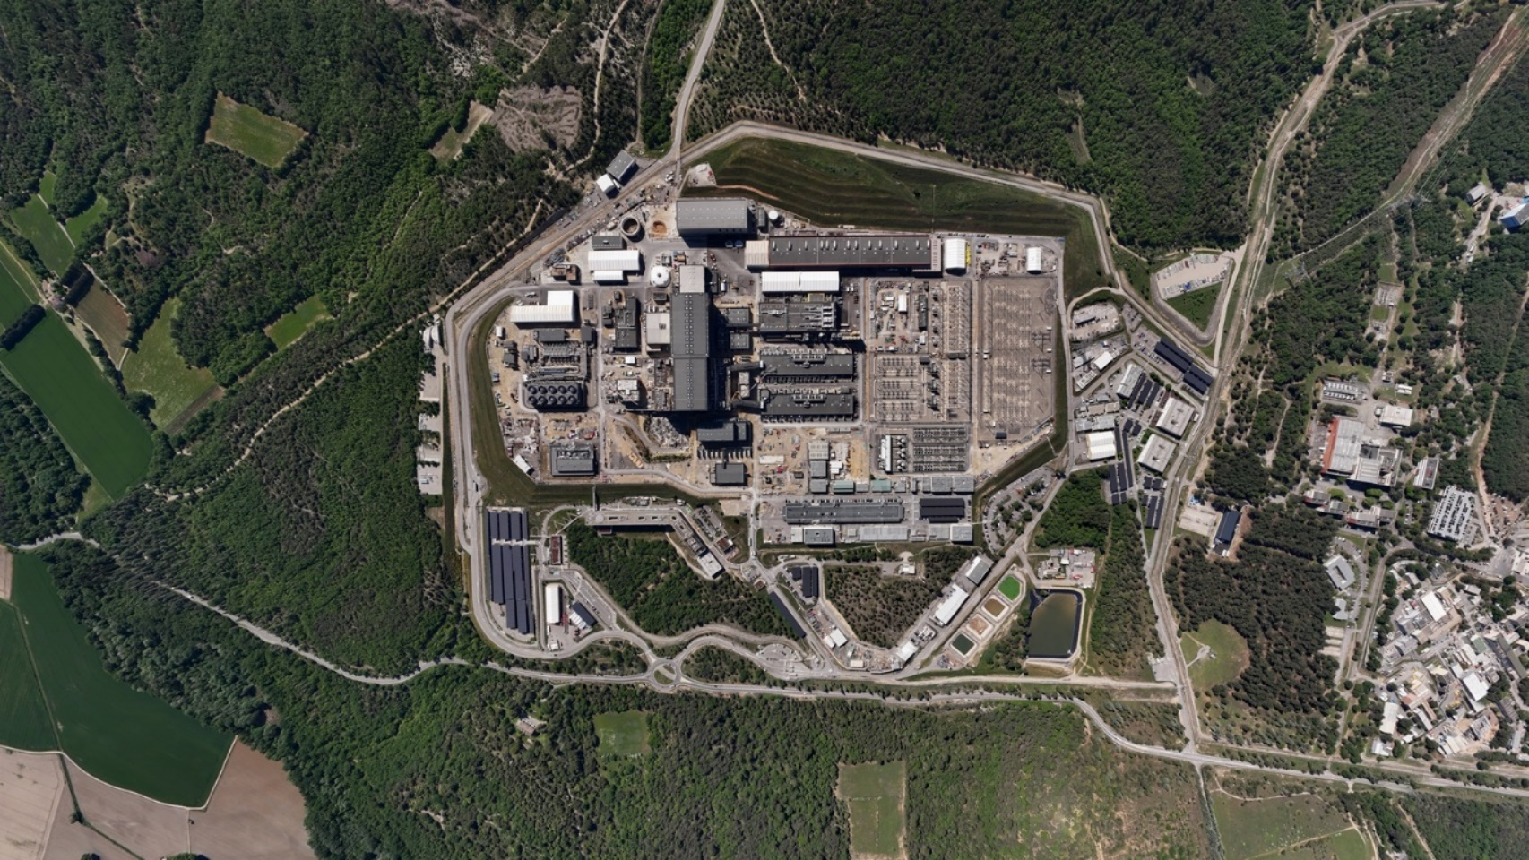
K3
B18
S1
K2
B63
B20
Figure 3: Aerial View of the New buildings locations
The intended Call for Proposal will focus on:
- Civil works which include concrete, primary and secondary steel structures, foundations (micro-piles for B63, bridges and any other foundation types).
- Finishing works which includes metallic works, doors (with appropriated fire rating when necessary), earthing, infrastructures works connection, rain-water drainage, cast in networks, partitioning, structural fire protection, false ceiling, false floor, painting/coating.
- Infrastructure works.
Exclusions from this CfT are:
- micro piles for B18,
- some external networks that will be performed before this present Task Agreement award under another mechanism,
- and the building services that will be subject to an In-Cash IO Call for Tender.

Notes:
- Direct nuclear experience on Protected Important Activities (PIA) activities is not required for this call. It is nevertheless important to note that as far as some buildings are Safety Related (to avoid damaging Protection Important buildings located in the vicinity in case of event – explosion, earthquake,…), specific measures have been included in the design.
- The Contractors of the DAs shall have experiences in Execution Design, building construction works in industrial complex environment with limited space and strong co-activities, writing & implementing relevant construction methods statements, and a strong Health & Safety and Environment policy supported by excellent safety performance ratios.
- The Contractors of the DAs shall have experiences to work within an international environment.
- The Contractors of the DAs shall have a strong Quality and Management system in place, and shall be qualified ISO 9001 or similar.

  - Overview of Buildings
    - ECH Building B18
This building will house Heating System and shall be located at the east of B14 (refer figure 2), and between B46 in the north and B61 in the south. The overall building dimensions are 66.0 m in length, 33.0 m in width and 19.8 m in height. This building has three levels on its north side (part of L1, L2 and L4) and two levels on its south side (part of L1 and L3) and a mezzanine level crossing north-south (L1M). The building also has a partial basement B1 of 88.9 m long x 20.1 m wide x 4.0 m height. The building is partially laid on the ground and loading micro-piles foundations. Micro-piles are out of scope but their connections with main structures are within the scope. Structurally the proposed design is made of the concrete slabs, beams and columns, and a metallic roof and bracing. Rooms are separated by partition walls made of plaster board or similar. The B18 basement is surrounded on its North side by two galleries and on its south side by one gallery. The Level 1 slab is in cantilever on the galleries. A rain water collector is located just below B1 level.

Out of scope scope

Figure 3: General layout of Building B18
Roofing and cladding are made of metallic element, including thermal/fire insulation, fixed on primarily structure with secondary elements.

    - ECH TL Bridge K2
The ECH Transmission Line (TL) Bridge K2 will connect building B18 to building B13. This bridge is housing transmission lines.
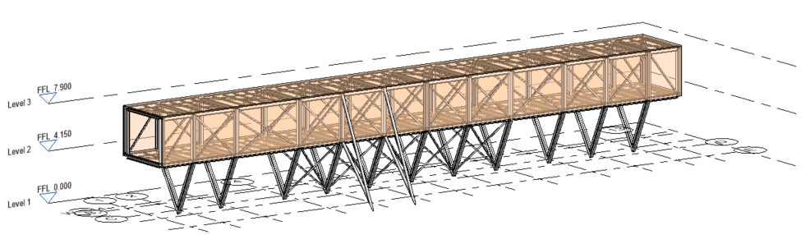
Figure 5: General layout of K2 bridge
The bridge is divided into two parts with an expansion joint in between:
▪ The western part, anchored on the B14 façade, and supported on the south retaining wall of the Seismic Isolation Pit, is 30 meters long.
▪ The eastern part, linked to B18, anchored on the B18 basement wall, is 18 meters long.
_A-A
A
A
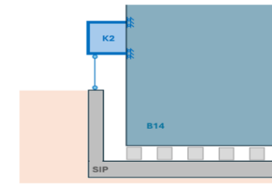
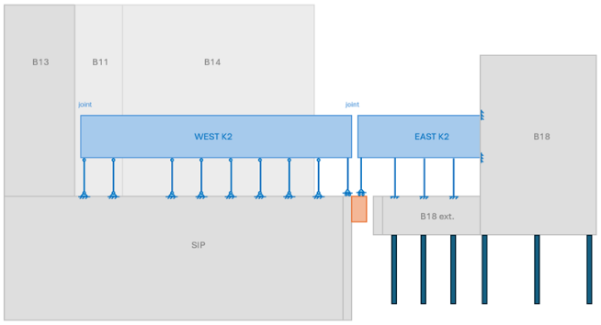
Figure 5: General layout of K2 bridge

The structure of about 4m x 4m section, is made of steel-trussed beams. These frames are repeated every 3.7 meters in the longitudinal direction with Saint Andrew’s crosses bracing the inclined planes.
The bridges facades and roofing are made of metallic elements and thermal insulations.

    - ICH Building B20
The building is located at the West of B17 and at the South of B75 (refer figure 2 above). It is a reinforced concrete structure with overall dimensions of 36.8 m in length, 18.9 m in width and 23.5 m in height. The roof and building bracing are made of metallic frame works. The building is resting directly on the ground through the lower slabs of the underground level. This building consists of three superstructure levels (L1, L2 et L3) and a basement (B1) with a clear height of 3.3 m. Rooms are separated by partition walls made of plaster boards or similar. A rain water collector is located just below B1 level.
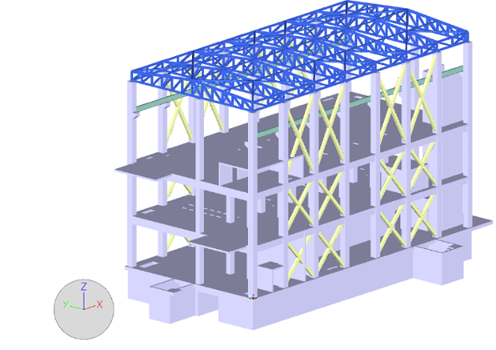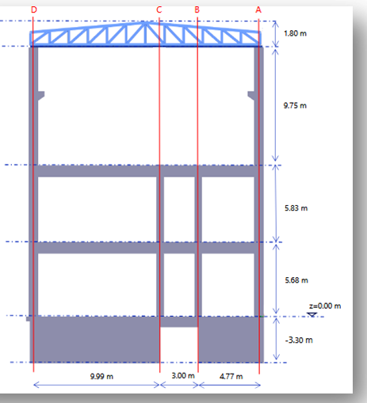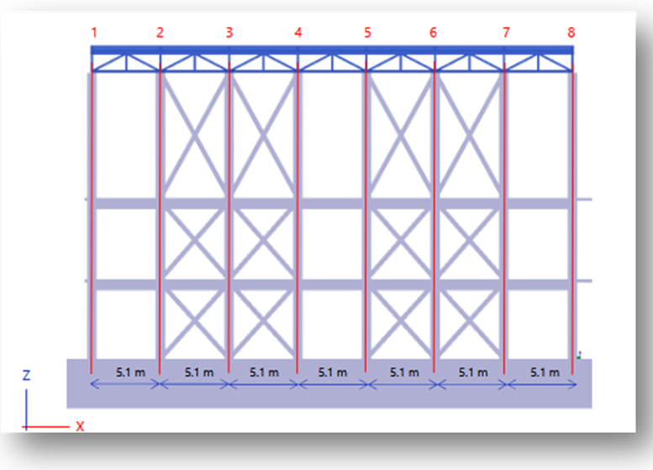
Figure 7: Building 20 cross sections.

At B1 level the building includes a basement traversed in the longitudinal direction by an existing gallery and in the transversal direction by another piece of gallery scheduled for demolition. The basement footprint measures approximately 36.3m length and 18.4 m in width, with a clear heigh of 3.3m.
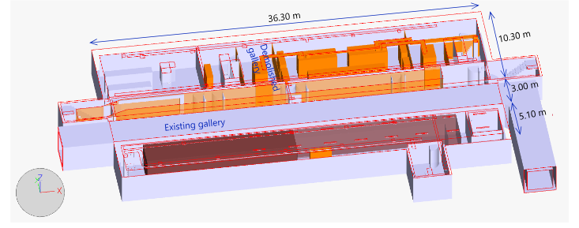
Figure 8: B20 basement

Roofing and cladding are made of metallic element, including thermal/fire insulation, fixed on primarily structure with secondary elements.

    - ICH TL Bridge K3
The bridge will connect the new building B20 to B13. It enables the routing of transmission lines.
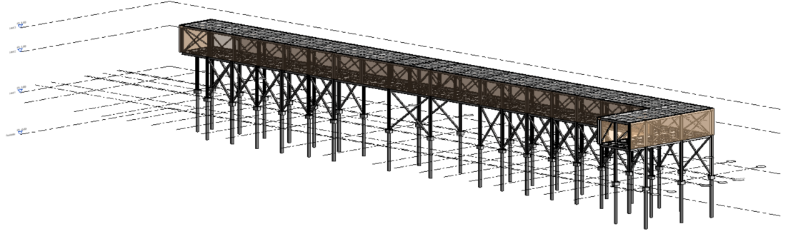
Figure 8: Global view of the bridge K3

The bridge runs all along the west facade of B13 and will be located below the existing bridge and above the road. It will be supported by the B13 main steel structures and foundations, and with dedicated micro-piles.
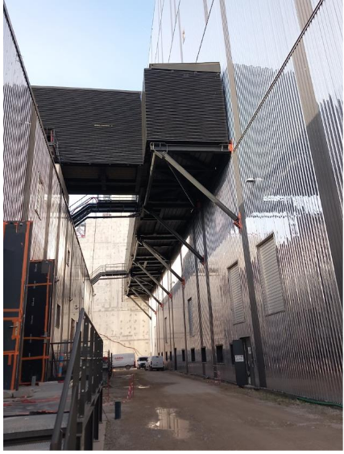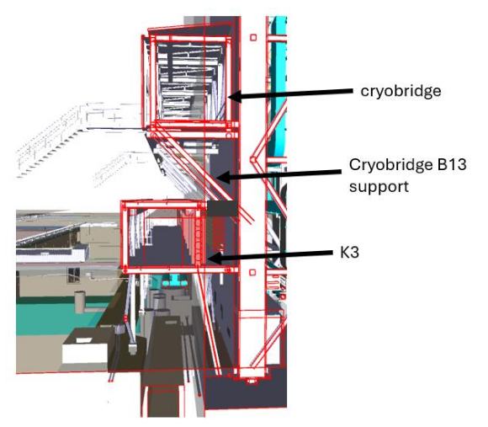
Figure 9: Picture of the cryo-bridge (left) and future bridge K3 underneath existing bridge (on the right)

The bridge structure is a steel frame, and the dimensions are the following:
- Total Length: 83.7m
- Box width: 3.9m
- External column high: 5.25m
- Box height: 3.45m
- Total Height 9m

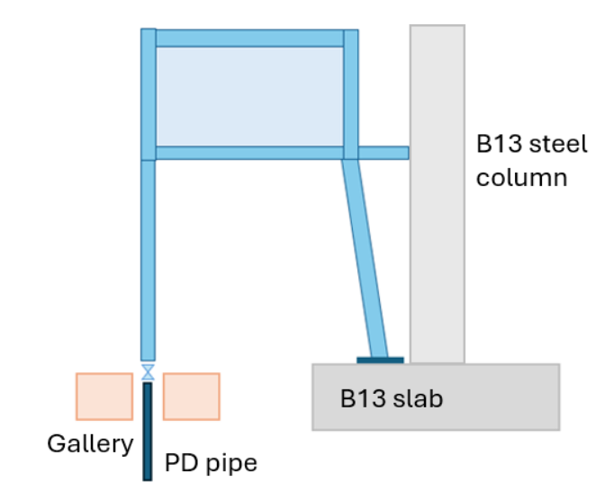
Figure 10: Cross section on the bridge K3

Roofing and cladding are made of metallic element, including thermal insulation, fixed on primarily structure with secondary elements.
    - New Cooling Water Building B63

The building B63 is located at North-East of building B18. Its dimensions are 48m long, 15m wide and 14.5m high (from ground level). The building has two main levels and mezzanines. Building foundations are designed to be micro-piles and beams which total depth is 8m from ground level as well as independent foundations for rotating machines. The superstructure is a steel structure with partition walls made of plaster boards or similar.
Roofing and cladding are both made of metallic elements, including thermal insulation, supported by secondary structure attached on the primary one.

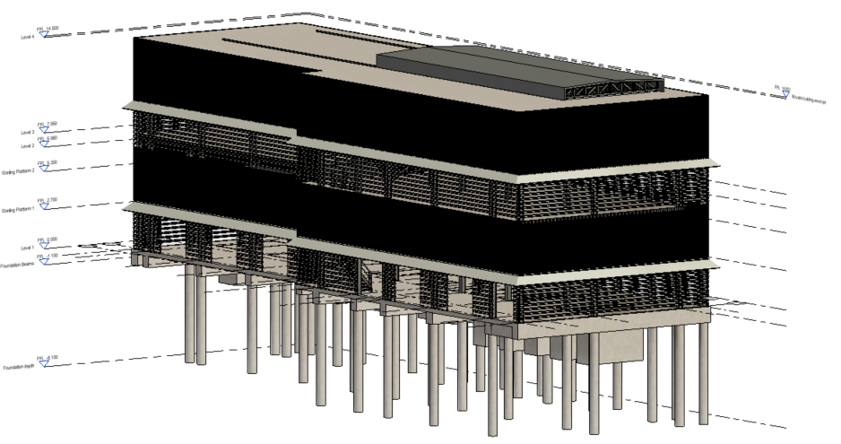
Figure 11: Global view of building B63
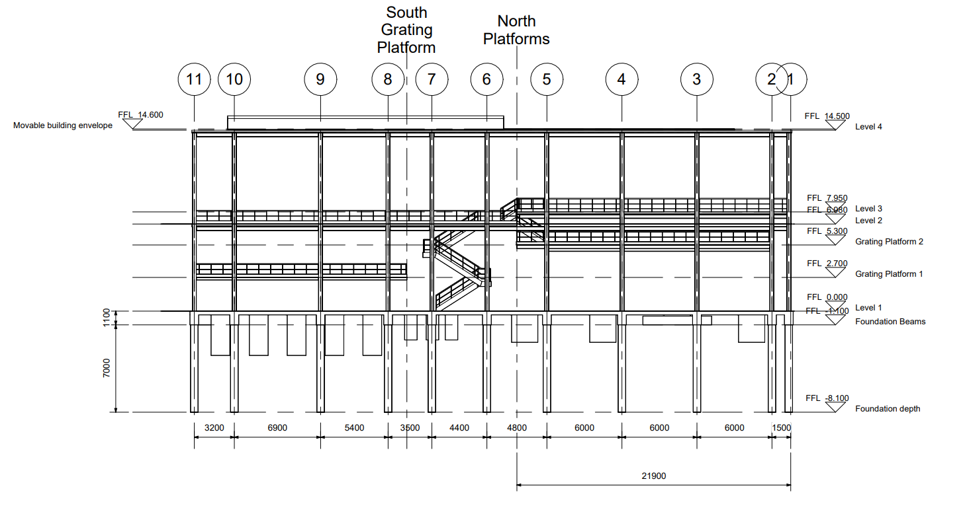
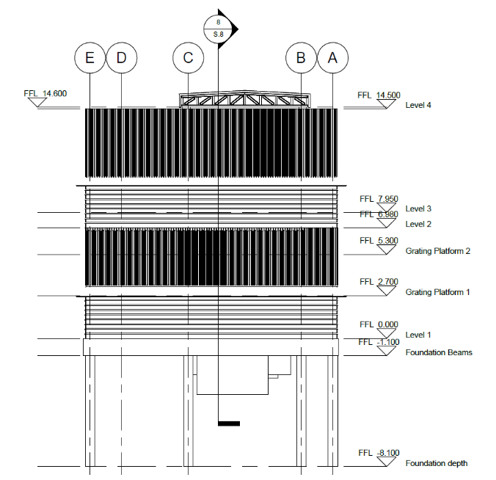
Figure 12: Vertical section of building B63

    - Infrastructures
The infrastructure works can be defined within each area:
B20 Area:
Preparation works:
- A small tunnel made of precast elements linking two tunnels will need to be dismantled and the openings closed
Final works:
- A road reshaped at the North of B20.
- A road to be implemented at the South of B20, between B20 and future extension.
B18 Area:
Preparation works:
- Before civil works of B18, some networks will need to be temporarily rerouted and definitively installed once the basement will be finalized (industrial, sanitary drainage, vacuum networks).
- Two opening on existing tunnel on the South shall be performed.
Final works:
- A road reshaped at the South of B18.
B63 Area:
Preparation works:
- Before civil works of B63, some networks will need to be rerouted (industrial, sanitary drainage, vacuum networks and water networks) in order to ease the cooling water pipes to be installed from B18 to B63.
- A relocation of a rainwater manhole.
- Two openings on existing tunnels at the South of B63 shall be performed (cooling water and electrical tunnel).
Infrastructure works for cooling water supply:
- The cooling water pipes linking B18 & B63 need to be installed on the buried part from B18 up to crossing the road at the East (excavations in green below).
- The cooling water pipes linking B18 & B63 require a rack structure from B63 to the South. This structure supports the pipes going to B18 and the supply/return pipes coming from Eastern area (rack in red below).
- The cooling water pipes providing supply/return water from Eastern area require foundation to be installed all along their routing (foundations in orange below).
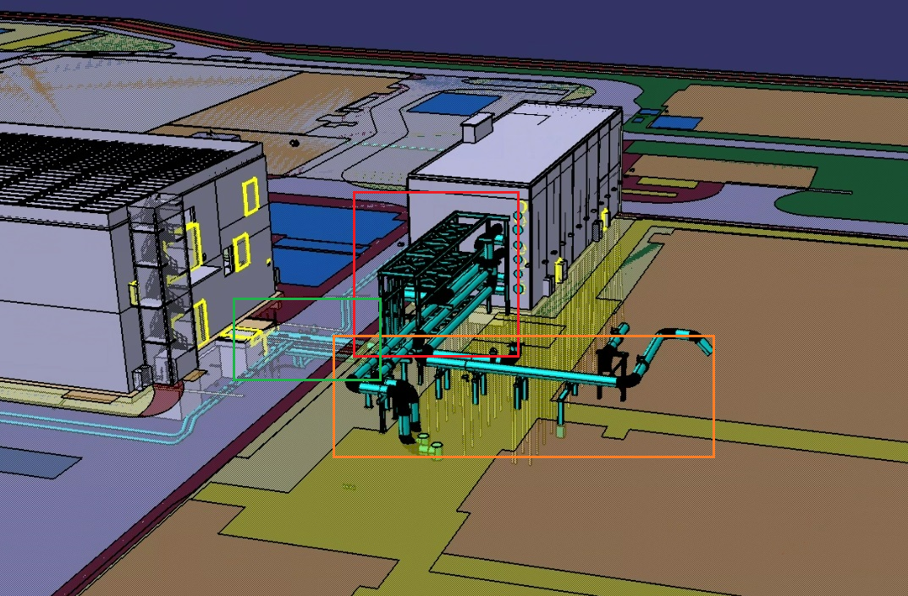

Final works:
A road reshaped at the North of B63.

    - Common works for all areas
Before erecting the civil works of B18, B20 and B63, some networks will have to be removed (as already re-routed within the preparatory works).
Just after the excavations of B18 / B20 / B63, some closure of manholes on tunnels and on rain water collector pipes will be necessary in order to allow the pouring of the basement slabs of the buildings.
The definitive connections will need to be implemented for each building (drainages, liquid and gas supply).
Roadworks and adaptations shall be performed all around each building.
- Call for Proposal

At the stage of the issuance of this Call for Proposal, it is important to note that the input technical package includes:
- The Final Design for the B18 and Building 20 and related infrastructures as per the Final Design Review of Buildings B18 and B20_New RF Heating Buildings, Bridges and Infrastructures_ Design Review Input Data Package List (IDP-List) (F5KYUW).
- The Preliminary Design of the bridges K2 and K3 as per the Preliminary Design Review_New RF Heating Buildings, Bridges and Infrastructures_Input Data Package List (IDP-List) (CXT7DH). The Final Design for the bridges K2 and K3 will be delivered by the IO beginning of April 2026, including the Final Design of the 3 EOT cranes in B18 and B20, and B20 lift.
- The Preliminary Design of the Rack S1 and remaining site infrastructures as per the Preliminary Design Review_New RF Heating Buildings, Bridges and Infrastructures_Input Data Package List (IDP-List) (CXT7DH). The Final Design for the Rack S1 and site infrastructures will be delivered in April 2026.
- The Preliminary Design of the B63 as per the Preliminary Design Review_New RF Heating Buildings, Bridges and Infrastructures_Input Data Package List (IDP-List) (CXT7DH). The Final Design for the Building 63 will be delivered in May 2026.

This approach aims at allowing sufficient time for the DA to prepare its industrial organization and consult its supply chain. DA and its supply chain will then finetune the financial proposal with the complementary elements delivered at the beginning of April and May, in view of a DA binding technical and financial proposal as per schedule below.
In particular, B63 and Rack S1 information description are based on Preliminary Design configurations, which will require a revision based on Final Design configuration evolution.

- Call for Proposal Schedule
IO issue of Call for Proposal: 20-Feb-2026
DA acknowledgement of intention 06-Mar-2026
Deadline for IO transmission of complementary technical elements: 10-Apr-2026
Deadline for IO transmission of the Final Design for Building 63 15-May-2026
Deadline for DA to issue clarification requests: 22-May-2026
Deadline for IO to issue clarification: 29-May-2026
Deadline for DA to submit proposal: 17-June-2026

It is intended that the TA is signed in July 2026 allowing to start the works activities (Execution Design) in October 2026 at the latest.

- DA Acknowledgement of Intention
It is kindly requested that DAs which expressed interest in the previous consultation phase formally confirm to the IO their intention to submit a proposal (or not) no later than 06-Mar-2026.

- Technical Specifications
The technical specifications are issued from the design phase performed under IO direction by the F4E contractor B.Next.

Organization of the technical documentation:
The technical documentation is split in annexes focusing on specific activities required to cover the entire technical scope.

- Draft Annex B with sub annex for CW scope:
Annex B.00 - General Technical Specification for Civil Work and Finishes
Annex B.01 - General Technical Specification for Concrete Works
Annex B.02 - General Technical Specification for Steel Structures
Annex B.03 - General Technical Specification for Earthworks
Annex B.04 - General Technical Specification for Micro-piles
Annex B.05 - General Technical Specification for Earthing and Lightning
The following annexes related to finishes scope are still under elaboration:
Annex B.06 - General Technical Specification for Cladding and Roofing
Annex B.07 - General Technical Specification for Metal Works
Annex B.08 - General Technical Specification for Interior Finishing
Annex B.09 General Technical Specification for Doors
Annex B.10 - General Technical Specification for Painting and Coating
Annex B.11 – General Technical Specification for infraworks
Annex B.12 - General Technical Specification for cranes and lifts
Annex P - Known Interfaces , co activities and site organization

The activities included in the scope of works are foreseen to be performed on the ITER site.
Main Applicable document is
ITER_D_YX55YY - General Management Specification for Executing Entities at the ITER Site

- Preliminary Schedule for the Construction

Milestone | IO internal target date
Start of Execution Design | Q3 2026
End of Execution Design | Q1 2027
Start of B18/B20 work on site | 05/01/27
RFOC B18/B20  Note: this shall include all other structures, bridges and infrastructures included within the scope of this call | 09/04/29
End of construction activities B18/B20  Note: this shall include all other structures, bridges and infrastructures included within the scope of this call | 31/08/29

The Tenderers are encouraged to propose any potential acceleration within the construction activities aiming to deliver the buildings and bridges Ready For Equipment before the L1 schedule dates.

- IO Contact Points

Technical contacts
Yves BELPOMO – BSM Program Manager yves.belpomo@iter.org
Laurent PATISSSON – BSM CEI Project Leader laurent.patisson@iter.org
Armand GJOKLAJ – BSM CEI TA Responsible Officer armand.gjocklaj@iter.org

Procurement contacts
Biswanath SARKAR – PSI Biswanath.Sarkar@iter.org
Paola MIELE, IO Procurement Division paola.miele@iter.org
always with copy to ta@iter.org

- Evaluation Process
  - Overview
Proposals will be evaluated by the IO evaluation team. The award methodology is Best Value For Money. Each proposal will be evaluated with full score of 60 technical points and 40 financial points (Total 100 points). The proposal which receives the highest points will be considered for award, and the IO will finalize the Task Agreement with the relevant DA.

  - Prerequisite: Mandatory Requirements prior to Evaluation
DA’s nominated contractor shall:
- Possess valid ISO 9001 certification and/or demonstrate the quality system complying with the IO QA requirements.
- Be able to demonstrate experience in the construction of technical buildings in the vicinity of buildings in construction, commissioning or operation.
No proposal will be considered for evaluation unless the two above requirements are met.

  - Technical Criteria and Required Submission
The technical criteria in the below table will be used to evaluate DA technical proposal based on their chosen civil works contractors and associated supply chain. The proposal, if it receives 100% score, will get 60 points. If the score is not 100%, the below formula will be applied:
Technical points = evaluated score/100 x 60 points
Only the technical proposals passing the minimum technical points of 36 points (60%) will be considered technically compliant, and be eligible for the financial assessment. It is highly recommended that the proposal should fully take into account the below criteria and include the required information accordingly.
DA will provide a compliance matrix explaining where to find the answer to the criteria in the technical file.

Technical Criteria and Required Submission | Score  (max 100)
1. Technical and Construction Manufacturing Capabilities | 30
1.1 Experience and Expertise  - Provide 3 examples of the construction of similar buildings.  - Demonstrate experience in erecting buildings in a very dense Construction environment (in the vicinity of other buildings under construction, commissioning or operation) with positive performance record. | 10
1.2 Compliance with Standards  - Provide 2 examples of projects executed according to ISO, EN, or ASME standards and/or projects utilizing standards similar to the ITER code. | 10
1.3 Quality Assurance  - Provide all relevant standards, including ISO 9001 and ISO 14001 for environmental management systems and relevant certifications on quality, health and conventional safety and environment.  - Provide a draft Quality Plan covering the works specified in the technical specification, in accordance with ITER quality requirements. | 10
2 Construction Process and Controls | 30
2.1 Compliance with the requirements  - Quality of the proposal for the construction programme: assessment in terms of details, exhaustiveness, compliance with the Time for Completion Sections and Milestones and adequacy with the constraints identified. | 10
2.2 Construction methodologies and planning  - Present the methods and phasing intended to be adopted in the execution of the works  - Provide an overall construction schedule, following the TS requirement and due dates, ensuring alignment with the ITER's overall timeline and requirements. Identify the critical path among construction activities. Demonstrate the ability to control project timeline with evidence of project management software used (e.g.: MS project, Primavera...)  - Provide a draft Inspection and Test Plan (ITP) covering the construction activities. | 5  10  5
3 Management, organization and personnel | 30
- Provide a draft of the project management structure, including roles and responsibilities; especially, the interaction between the DA, the contractor and the IO and the field resources foreseen to be deployed on the ITER site for the execution of the works. The description of the organization to be deployed for the coordination, supervision and management of the works (on site and back office resources). Provide the CVs of key personnel, focusing on individuals for critical activities/processes and any certification documentation.  - Demonstrate the capacity of the chosen constructor to access and deploy on site all relevant resources needed to perform the scope object of the TA, including the description of the Health and Safety organization to perform the works (considering the congested and limited space and the coactivity). | 15  15
4 Documentation, traceability and Compliance | 10
- Provide an example on the way the documentation is managed by the contractor and in particular its capacity to prepare, maintain and deliver an exhaustive completion dossier (including the as-built files, NCRs, Deviation Requests, …) at the end of the construction phase  - Present the way the snags resolution works are followed up, to fully close all snags and remaining works in the 4 months following the end of the works (except specifically justified and agreed by the IO). | 5  5

  - Financial Criteria and Required Submission
Please provide a financial proposal which includes;
    - the firm and fixed price to execute the scope (total price),
    - payment schedule,
    - the detailed cost breakdown (including labor, raw material, equipment, indirect costs etc),
    - the filled-in Bill of Quantities to be used to quote variations in case of evolutions of the scope.

Total Price
Total Price will be used for evaluation. The lowest priced proposal will receive 40 points.
The other proposals will receive points according to the below formula;
Financial points = [lowest proposal from other DA / the proposed price of the relevant DA] x 40

Payment Schedule
Please propose a payment schedule using the below template. Since this is Task Agreement in Cash, payment is possible only in EURO currency.

Phase | Duration  (month) | Start (T0+) | End (T0+) | Activities | Payment Milestone  (upon phase completion in %) | Payment Amount in EUR
Site mobilization of the contractor | 6 | 0 | 6 | Schedule, Quality Plan (supplier and Major sub-suppliers), Inspection and Test Plan, List of subcontractors, Execution Design, construction methods, Material Specification  Coordination lan, PPSPS, PRE and request for accesses of the contractor on site.  Site Construction facilities (if any) installed. | 5 | To be added
B18 construction | 26 | 6 | 32 |  |  | To be added
Foundations & Basement |  |  |  |  | 10
Superstructures |  |  |  |  | 15
B20 Construction | 26 | 6 | 32 |  |  | To be added
Foundations & Basement |  |  |  |  | 10
Superstructures |  |  |  |  | 15
B63 Construction | 18 | 14 | 32 |  |  | To be added
Foundations & Basement |  |  |  |  | 10
Superstructures |  |  |  |  | 10
K2 Bridge | 12 | 6 | 18 |  |  | To be added
Foundations |  |  |  |  | 5
Superstructures |  |  |  |  | 5
K3 Bridge | 12 | 6 | 18 |  |  | To be added
Foundations |  |  |  |  | 5
Superstructures |  |  |  |  | 5
Rack S1 | 6 | 26 | 32 |  | 5 | To be added
 |  |  |  | Total Amount | 100% | To be added

Cost Breakdown
Please submit the detailed cost breakdown (labor, raw material, equipment, indirect costs etc).
Please use the attached cost breakdown form.
NOTA: QUANTITIES TO BE UPDATED

  - Submission of Proposal
DAs are requested to submit a technical and financial proposal as two separate documents.
Please send them by email to ta@iter.org before the date as defined in the CfP schedule in Section 4 (17-June-2026).

  - Proposal Validity
The proposal shall be valid for 6 months.

  - Language.
The official working language of the IO is English. The proposal, any information and correspondence shall be submitted only in English language.

  - Expenses for Proposal Preparation
IO will not reimburse any expenses incurred in connection with preparation and submission of proposal.

- Draft Task Agreement
With the selected DA, the IO will finalize the Task Agreement using usual normal template and incorporating/attaching the Technical Specifications and complementary information distributed along the Call for Proposal Process.

- Any Other Questions
Please send any query to the IO contacts indicated in Section 8 above.

===end of the document===

